EXPERIMENT NO. 01
Object: To plot the V-I characteristics of Zener Diode.

Apparatus required: Zener diode kit, (having an in built voltmeter, ammeter, battery, Zener diode, switches, rheostat) and patch chords.

CIRCUIT DIAGRAM:

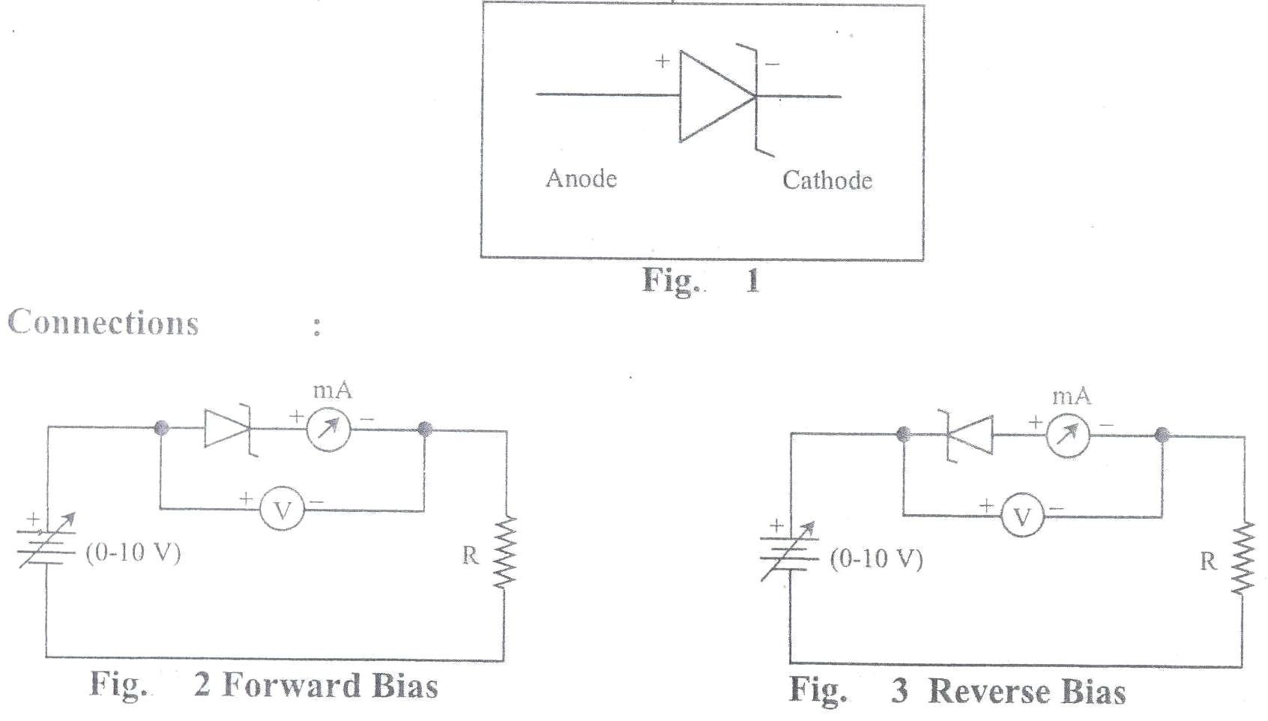

Theory: The Zener diode is a silicon crystal diode having special reverse current characteristics. In Zener diode as the reverse voltage applied to p-n junction is increased a limit comes when the current increases very rapidly form its cut off value and the zener diode begins to behave almost like a conductor. This limiting voltage is called the “zener voltage” or “breakdown voltage” and the resulting large current as ‘zener current’.
A Zener diode is a special kind of diode which allows current to flow in the forward direction in the same manner as an ideal diode, but will also permit it to flow in the reverse direction when the voltage is above a certain value known as the breakdown voltage, "Zener knee voltage" or "Zener voltage." The device was named after Clarence Zener, who discovered this electrical property.

The mechanism of breakdown in zener diode: New charge carriers (electrons and holes) are liberated when thermally exited charge carriers acquired sufficient energy from the applied potential and break the covalent bonds. The newly generated charge carriers further break the bonds in crystal and generate more charge carriers then the current increases at very rapid pace without increasing the applied voltage.
The breakdown can be controlled by amount of impurity in the semiconductor the nature of electrodes and the techniques employed to form the zener diode symbolic representation of zener diode. The circuit diagram, graph and symbol of zener diode shown below:

Procedure: The experiment is performed in the following two steps:-
- In forwards bias (b) In reverse bias
- In Forwards Bias:
Connect the electric circuit as shown in fig.2 for this battery is connected to the P-terminal of Zener diode and the negative terminal to the N-terminal. To read current in the circuit millimeter and to read the applied potential, a voltmeter is connected. Take care that the ‘+’ marked terminals of voltmeter and millimeter are connected to the positive terminals of the battery. Different potential are applied on the Zener diode & corresponding to reach potential the reading of millimeter is noted.
- In Reverse Bias:
Connect the electric circuit a shown in fig. 2. The P terminal of Zener didoe is connected to the negative terminal of the battery and N-Terminals to the positive terminals of the battery. To read current in the circuit. micro ammeter(µA) is connected and to read the applied potential, voltmeter V is connected. Take Care that the positive marked terminals of Voltmeter and micrometer are connected to the Positive terminals of the battery.
- Plot the curve on the graph paper taking voltage on x-axis and current on y-axis for forward bias and reverse bias as show in figure 4.

Observations:
Least count of voltmeter = …………….. Volt
Least count of Milli ammeter = ……………..Milli ampere

OBSERVATION TABLE:

S.No | Forward Bias |  | Reverse Bias
S.No | Voltage V (in volts) | Current I (in mA) | Voltage V (in volts) | Current I (in mA)
1.
2.
3.
4.
5.

Result: Characteristics of Zener Diode in Reverse Bias and Forward Bias are as shown in the attached graph.

Precautions:
- Connections should be made properly and tightly.
- At least five reading should be taken.
- A free hand graph should be plotted.

Viva questions:
- What do you mean by least count?
----------------------------------------------------------------------------------------------------------------
- What is zener diode?
----------------------------------------------------------------------------------------------------------------

- What is meant by zener breakdown?
----------------------------------------------------------------------------------------------------------------

- How zener diode overcomes pn junction diode?
----------------------------------------------------------------------------------------------------------------

- Tell any three applications of zener diode.
----------------------------------------------------------------------------------------------------------------

EXPERIMENT NO. 02

Object: To plot the V-I characteristics of a PN junction diode.

Apparatus required: PN junction diode kit, Voltmeter (3V-30V), Ammeter (100µA-10mA)
chords, power supply (3V-30V).

CIRCUIT DIAGRAM:

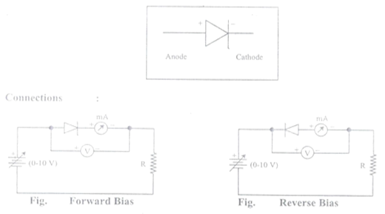

Theory: Based on the electrical conducting properties, materials can be classified into three types as metal, insulator and semiconductor. In the case of insulators there is a large value for energy gap between the valence and conduction band. Hence, they have large value of resistance R. For semiconductors, the value of energy gap of is comparatively less in comparison with the insulators. Therefore they posses moderate value of R. In the case of metals, the valence and conduction band overlaps with each other and hence considerable amount of free electrons are available for electrical conduction. Due to this the value of resistance is very small when we compare with semiconductors and insulators. There are two types of semiconductors namely P type and N type. In P type semiconductors the majority charge carriers are holes and in N Type semiconductors the majority charge carriers are electrons. When we join P and N type semiconductors, near the junction the holes from P type and electrons from N type join together by diffusion. Due to this the holes and electrons recombine at the interface. It creates immobile neutral ions at the interface in the form of a barrier. This barrier prevents further movement of holes or electrons from P to N or from N to P. This layer or barrier is called as depletion layer.
Forward bias: When we join the positive terminal of the battery or voltage source to the P type and negative terminal to N type then it is called as forward bias. Under this condition the thickness of the depilation layer will decrease. Thus by allowing the movement of majority charge carriers across the diode. Therefore the current will start to flow. If we increase the value of voltage the current value also will increase. The circuit diagram, graph and symbol of PN junction diode in forward biasing condition has been shown in figure.
Reverse Bias: An external volotage applied with piolarity in fig. is called reverse bias. When reverse bias is applied to a junction didoe the depletion region does not collapse. On the countrary, it becomes wider. The positive side of battery is applied to then-type material. This attracts the free electrons away from the junction. The negative side of the battery attracts the holes in p-type material away from the junction. This makes the depletion region wider than it was when no voltage is applied. The depletion region is an insulator. And it will bolck the current, Actually a small current will folw because of minortity carriers. The p-type material has a few minority electrons. These are pushed to the junction by the repulsion of the negativee side of the battery. The type material has few minotity holes. These are also pushed towards the junction. Reverse bias forces the minority carriers together, and a small current called leakage current. The circuit diagram, graph and symbol of PN junction diode in Reverse biasing condition has been shown below:

Procedure:
Forward Bias Characteristics:
- Make all the connections as shown in figure. using patch cords for forward bias.
- Keep 3V/30V switch at 3V side & 100µA/10mA at 10mA side.
- Keep set volts 3V/30V Switch at 3V DC.
- Keep Potentiometer Knob’s at extreme left side.
- Switch ON the instrument using ON/OFF Indicator switch provided on the front panel.
- Set the voltage at 0.2v and note down the corresponding current reading in the Table .
- Keep on increasing voltage in the steps on 0.2V & note down corresponding current in the Table.
- Plot a graph for forward bias by taking voltage along x- axis and current along y-axis.

Reverse Bias Characteristics:
- Make all the connections as shown in figure using patch cords.
- Keep 3V/30V switch at 30V side & 100µA/10mA at 100µA side.
- Keep set volts 3V/30V Switch at 30V DC.
- Keep Potentiometer Knob’s at extreme left side.
- Switch ON the instrument using ON/OFF Indicator switch provided on the front panel.
- Set the voltage at 0.2v and note down the corresponding current reading in the Table .
- Keep on increasing voltage in the steps on 0.2V & note down corresponding current in the Table.
- Plot a graph for reverse bias by taking voltage along x- axis and current along y-axis.

Observations:
FORWARD BIAS
Least count of voltmeter = …………….. Volt
Least count of Milli ammeter = ……………..milli -ampere
Observation table:
S. No. | Reverse Voltage (in Volts) | Reverse Current (in µ- Ampere)
1
2
3
4
5
6

REVERSE BIAS
Observations:
Least count of voltmeter = …………….. Volt
Least count of µ ammeter = …………….. µ ampere
Observation table:
S. No. | Forward Voltage (in Volts) | Forward Current (in Milli Ampere)
1
2
3
4
5
6

Result: The Characteristics curve of P-N junction diode is shown in attached graph.

Precautions:
- Connections should be made properly and tightly.
- At least five reading should be taken.
- A free hand graph should be plotted.
- The potential applied on the diode must be kept below its safe limit.
- Current should not be passed for long time through the diode.

Viva questions:
- What is PN junction diode?
----------------------------------------------------------------------------------------------------------------
- What is meant by forward and reverse bias in a diode?
----------------------------------------------------------------------------------------------------------------
- What are semiconductors?
----------------------------------------------------------------------------------------------------------------
- What is doping?
----------------------------------------------------------------------------------------------------------------
- Can a semiconductor behave as an insulator?
----------------------------------------------------------------------------------------------------------------
- Which type of impurity is added in P-type and N-type semiconductors

EXPERIMENT NO. 03

Object: To determine the frequency of A.C. mains by using electrical vibrator in transverse mode.
Apparatus Required: Electrical Vibrator, bulb, pulley, weight box, thread chord and meter tape.
Formula Used: Frequency of AC Mains
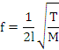
Where,
f= Frequency of AC mains
l = length of one loop
T = Tension on thread (= mg)
M = Mass per unit length of the thread

Theory: When the solenoid is connected to the AC mains, alternating magnetic field is produced along its axis and the axial rod is magnetized in such a way that the end of the rod becomes alternatively north and south. Thus the rod is alternatively pulled towards the South Pole and the North Pole and starts vibrating. The vibration in the rod has the same frequency as that of AC mains.
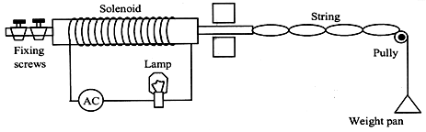
Procedure:
- The current is switched on and it is seen that the rod of the electric vibrator begins to vibrate. The length of thread is adjusted till it is found that its free end attains maximum amplitude.
- String is made to pass over the pulley and suitable weight is put on pan. The length of string is adjusted till is found that nodes are sharply defined. The length of the string between nodes and the number of loops are noted down. Calculate tension and compute n which is frequency of AC mains.
- Repeat this experiment with different weights.

Observations:
Least count of weight box=……………..gm.
Least count of meter tape =……….…….cm.

- Mass of the pan (m₁) = 22.6 gm
- Mass of thread per unit length (M) = 0.00210gm per cm.
- Acceleration due to gravity(g) = 980 cm/sec²
Observation Table:
S.No. | mass on pan (m₂) (in gm) | Total mass m =  m₁ +m₂  (in gm) | Tension T = mg | Number of loops(n) | Length of thread L (in cm) | Length of one loop  l = L/n
1
2
3
4
5

Calculation:
Frequency of AC mains
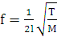
f₁ = ……………. Hz
f₂ = ……………. Hz
f₃ = ……………. Hz
f₄ = ……………. Hz

Thus mean f = 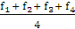

Result: The frequency of AC mains = …………… cycle/sec or Hz
Standard value of frequency of AC mains = 50 cycle/sec or Hz

% Error: 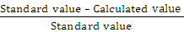x 100
= ………………… %

Precautions:
- There should not be friction in the pulley.
- The thread should be thin, uniform and inextensible.
- The measurement should be taken in the maximum amplitude position of the loops.
- The nodes and antinodes should be sharply defined which justify the optimum weight put on the pan.
- The weight should not be more than 35 gm on the pan, otherwise the thread will break.

Viva Questions:
- What do you understand by electrical vibrator?
----------------------------------------------------------------------------------------------------------------
- What do you mean by AC mains?
----------------------------------------------------------------------------------------------------------------
- What are a solenoid and its function?
----------------------------------------------------------------------------------------------------------------
- What do you mean by waves?
----------------------------------------------------------------------------------------------------------------
- What are nodes and antinodes?
----------------------------------------------------------------------------------------------------------------
- Why do we use bulb in the experiment?
----------------------------------------------------------------------------------------------------------------
- Define frequency?
----------------------------------------------------------------------------------------------------------------
- What is the standard value of frequency in your experiment?

----------------------------------------------------------------------------------------------------------------

EXPERIMENT NO. 04

Object: : To draw the Input, Output and Current transfer characteristics of a PNP transistor connected in common Base configuration.
Apparatus required: The apparatus and components required for performing the experiment are:
- Power supply with two outputs (0-1V & 0-10V)
- Two voltmeters (0-1 V and 0-10 V)
- One Milli ammeter (0-50 mA) and One Micrometer (0-250 uA)
- An PNP transistor characteristic kit module No.ME533D

Theory: When the transistor is connected with its base terminal common to both the input junction and the output junction, it is said to be connected in common base configuration. The connection for an pnp transistor is illustrated in fig below where voltmeters and ammeters are included for measurements.
The three regions are called emitter, base and collector. The base region is lightly doped as compare to the other two regions, The emitter is heavily and collector region is moderately doped. The width of the base made thin as compare to emitter and conductor to reduce the combination of base region .Both the holes and electrons present in the semiconductor regions of the transistor contribute the current and hence it is called bipolar junction transistor.
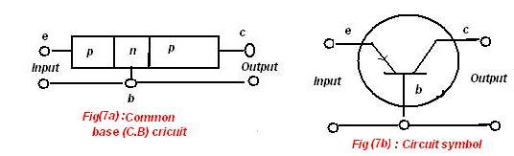

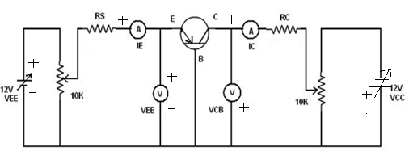
Procedure: Connect the electrical circuits.Keep the meter selector switch on microampere side. In the connections collector bias as well as base bias both are negative with respect to emitter.
Input characteristics: To determine the input characteristics in CB configuration, the output voltage V_{CB} is held constant and the input voltage V_{EB} is set at different values. For each setting of V_{EB}, the input current I_{E} is noted. The input characteristics curves are plotted as shown. in Fig.
Adjust collector to base voltage V_{CB} at some suitable value and keep it constant.By adjusting input supply set the emitter current to a small but measurable value say 5mA,note down the corresponding emitter to base voltage V_{EB}.Increase V_{EB} in small steps and note down the corresponding emitter current I_{E.}
The curves are very much similar to the forward bias characteristic of a pn-junction. It is so because the EB-junction is forward biased. For a given V_{EB}, I_{E} increases slightly with V_{CB}. This is because larger reverse bias across CB junction causes widening of the CB junction regions. This in turn reduces the distance and the resistance between EB and CB junction regions.
Output characteristics: The output characteristics are plotted between the collector current Ic and the collector-base bias V_{CB} is keeping the emitter current I_{E} constant. For each fixed value of I_{E}, the output voltage V_{CB} in convenient steps and the corresponding collector current values are recorded from these a family of output characteristics such as those illustrated in Fig. Adjust the emitter current I_{E} to a suitable value set collector voltage V_{CB} to 0.5v and note the corresponding collector current I_{C}.Gradually increase the collector voltage in small steps and note down the corresponding values of collector current I_{C} keeping the emitter current I_{E} constant.

Transfer characteristics: Adjust collector voltage at suitable value and maintain it constant.
Adjust emitter current I_{E} to a suitable small but measurable value and note the corresponding collector current I_{C}. Increase I_{E} in small steps and note the collector current I_{C} each time. The forward transfer characteristics are obtained by keeping V_{CB} constant and measuring Ic for different settings of I_{E} shown in fig.
Observations table:
Least count of input voltmeter = …………….. Volt
Least count of output voltmeter = …………….. Volt
Least count of Milli ammeter = …………….. Milli ampere
Least count of Micro ammeter = …………….. Micro ampere

For input characteristics:

S.No. | V_{EB} (inVolts) | I_{E} (in mA)
S.No. | V_{EB} (inVolts) | At V_{CB} = 2V | At V_{CE} = 4V
1
2
3
4
5
6
7

For output characteristics:

S.No. | V_{BC} (inVolts) | I_{C} (in mA)
S.No. | V_{BC} (inVolts) | At I_{E} = 10 mA | At I_{E} = 20 mA
1
2
3
4
5
6
7

For current transfer characteristics: At V_{CB} = 2V

S.No. | I_{E} (in mA) | I_{C} (in mA)
1
2
3
4
5
6
7

Results: For the common Base mode of given PNP transistor; characteristics curves are plotted as shown in the attached graph.

Precautions:
- Connections should be according to the circuit diagram, neat and clean.
- Switch on the circuit before making all the connections.
- Readings should be taken carefully and perpendicularly.
- Table should not be disturbed otherwise fluctuations may occur.

Viva Questions:
- What is the aim of your experiments?
----------------------------------------------------------------------------------------------------------------
- In how many configurations we connect the circuit?
----------------------------------------------------------------------------------------------------------------
- Why the circuit configuration is called common base?
----------------------------------------------------------------------------------------------------------------
- What is the role of base? Why it is made thin and lightly doped?
----------------------------------------------------------------------------------------------------------------
- What is a transistor? How many regions are there in it?
----------------------------------------------------------------------------------------------------------------
- What do you mean by current gain in CB mode?
----------------------------------------------------------------------------------------------------------------
- Why α is always less than 1?
----------------------------------------------------------------------------------------------------------------

`

EXPERIMENT NO. 05
Object: To draw the Input, Output and Current transfer characteristics of a PNP transistor connected in common Emitter configuration mode.
Apparatus required: The apparatus and components required for performing the experiment are:
- Power supply with two outputs (0-1V & 0-10V)
- Two voltmeters (0-1 V and 0-10 V)
- One Milli ammeter (0-50 mA) and One Micrometer (0-250 µA)
- An PNP transistor characteristic kit module No.ME533D
Theory: In common emitter configuration the emitter is made common to both input and output circuits. Input is applied between base and emitter and the output is taken between collector and emitter terminals shown in fig. The bipolar junction transistor is fabricated with semiconductor region. The three regions are called emitter, base and collector. The base region is lightly doped as compare to the other two regions, The emitter is heavily and collector region is moderately doped. The width of the base made thin as compare to emitter and conductor to reduce the combination of base region .Both the holes and electrons present in the semiconductor regions of the transistor contribute the current and hence it is called bipolar junction transistor.

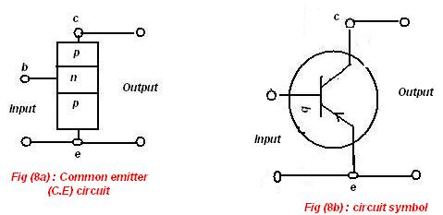
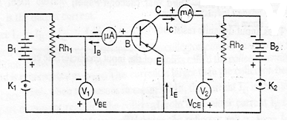

When a transistor is connected with emitter as the common terminal for both input and output it is called a common emitter connection or common emitter configuration. In this configuration the input is at the base and output is at the collector and the emitter is common for both input and output since I_{B} is the input current and Ic is the output current the gain is Ic/Ib. It is often called as static forward current transformation. In the common emitter due to the variation in the base current there is a large variation in the collector this property be used to work is as an amplifier.

Procedure:
Connect the electrical circuits as shown in the Fig. Keep the meter selector switch on microampere side. In the connections collector bias as well as bias both are negative with respect to emitter.
Input Characteristics
Adjust collector to emitter voltage V_{CE} at some suitable value and keep it constant.By adjusting input supply, set the base to emitter voltage, so that base current shows value say 20uA. Note down base to emitter voltage V_{BE} increase V_{BE} in small steps and note the corresponding base current I_{B.}
Plot graph by taking base voltage V_{BE} along x-axis and base current I_{B} along Y-axis.

Output Characteristics
Set collector voltage V_{CE} to 0.5v, Adjust the base current I_{B} to 50uA using VR1 and note down the corresponding collector current I_{C} . Gradually increase the collector voltage in small steps and note the corresponding values of collector current I_{C} keeping the base current I_{B} constant.
Plot graph by taking collector voltage V_{CE} along x-axis and collector current I_{C} along Y-axis.

Transfer Characteristic
Adjust collector voltage at suitable value and maintain it constant. Adjust base current I_{B} to a suitable small but measurable value and note down the corresponding collector current I_{C.} Increase I_{B} in small steps and note down the collector current I_{C} each time.
Plot a graph by taking base current I_{B} along X-axis and collector I_{C} along Y-axis

Observations:
Least count of input voltmeter = …………….. Volt
Least count of output voltmeter = …………….. Volt
Least count of Milli ammeter = …………….. Milli ampere
Least count of Micro ammeter = …………….. Micro ampere
Observations table:
For input characteristics:
S.No. | V_{BE} (inVolts) | I_{B} (in mA)
S.No. | V_{BE} (inVolts) | At V_{CE} = 2V | At V_{CE} = 4V
1
2
3
4
5

For output characteristics:
S.No. | V_{EC} (inVolts) | I_{C} (in mA)
S.No. | V_{EC} (inVolts) | At I_{B} = 100uA | At I_{B} = 150uA
1
2
3
4
5

For Transfer characteristics:
S.No. | At V_{EC}=2V
S.No. | I_{B} uA | I_{C} mA
1
2
3
4
5

Results: For the common emitter modes of given PNP transistor; characteristics curve are plotted in the attached graph.

Precautions:
- Connections should be according to the circuit diagram, neat and clean.
- Switch on the circuit before making all the connections.
- Readings should be taken carefully and perpendicularly.
- Table should not be disturbed otherwise fluctuations may occur.

Viva Questions:
- What is the aim of your experiments?
----------------------------------------------------------------------------------------------------------------
- How are the junction biased normally?
----------------------------------------------------------------------------------------------------------------
- Why the circuit configuration is called common emitter?
----------------------------------------------------------------------------------------------------------------
- What is the function of emitter?
----------------------------------------------------------------------------------------------------------------
- What is the basic difference between PNP and NPN transistor?
----------------------------------------------------------------------------------------------------------------
- Why CE configuration is supposed to best rather than CB and CC configuration?
----------------------------------------------------------------------------------------------------------------
- What do you mean by current gain in CE mode?
----------------------------------------------------------------------------------------------------------------

EXPERIMENT NO. 06

OBJECTIVE:
To determine the band gap in a semi-conductor material by using the temperature dependence of reverse saturation current.

APPARATUS REQUIRED:
P-N junction diode kit, Connection wires, Power supply, thermometer Temperatures controller and micro ammeter.

FORMULA USED: -
The band gap is given by
E_{g}=Slope of straight line/5.036=…..eV

THEORY:
In the conductor there is an energy gap between the conduction and valence band. For conductor a certain amount of energy is to be given to the electron so that it goes from the valence band to the conduction band. The energy so needed is the measure of the energy gap, ∆E between two bands. When p-n junction is reversed biased then current is a function of temperature of the junction diode for a small range of temperature. The relation is expressed as
Log Is = Constant – 5.036×∆E (10³/T),
Where temperature ‘T’ is in Kelvin, ∆E is in eV. A graph of Log Is vrs 10³/T is plotted which comes out to be a straight line. The slope of this line will be ∆E×5.036, thus giving the value of the band gap for the semiconductor.
Electrons moving within a crystal are confined to discrete energy levels or bands separated by regions for which there is no allowed state for motion for the electron, called energy gaps. The energy gap to be measured in this experiment is that between the valence and conduction bands of a semiconducting material. It is the size of this gap which, in part determines the electronic properties of semiconductors. The current passed by a semiconductor varies with temperature according to the relation.
I= I_{o}e ^{–E}_{g}/_{2kT}
Where I is the current of the device at a temperature T(K),I_{o} is the current at some reference temperature, E_{g} is the effective energy gap of the material and k is Boltzmann’s constant. Strictiy speaking E_{g} is not independent of temperature, but its variation is very small over the temperature range 20 to 90⁰c that is to be used in this experiment. Form the equation, a plot of log₁₀I_{s} verses 1/T will yield a straight line with a slope (-E/2K) from which the E_{g} may be calculated.
CIRCUIT DIAGRAM:
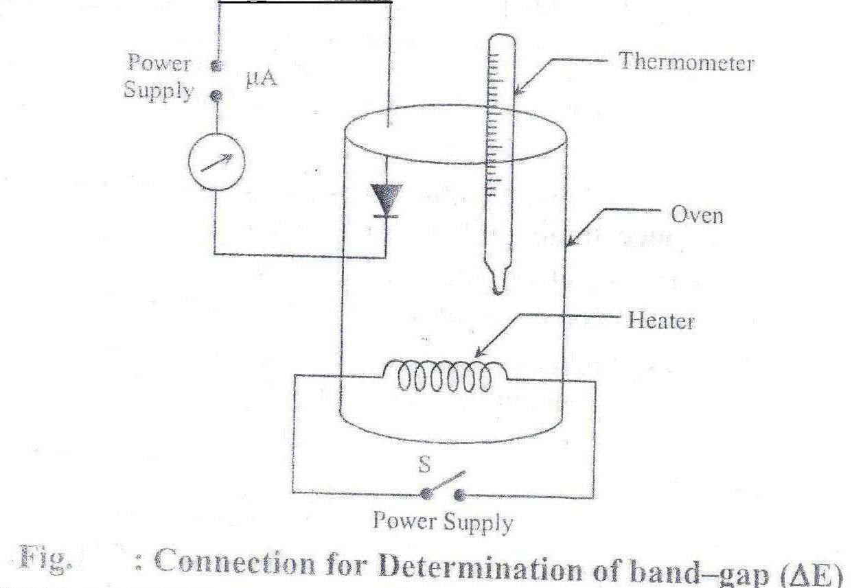

Procedure:-work out the following procedure:
- Connect the circuit shown in figure,
- Now insert the thermometer and switch on the oven.
- When temperature reaches up 65⁰c switch off oven.
- After switching of the oven the temperature will be not remain constant. It still increase up to 75⁰c and the decreases.
- At this position note down the value of current in (µA).
- Now note the value of current (µA) as the temperature decreases at 5⁰c.
- Now draw the graph between log₁₀I_{s} on Y-axis and 10³/T(k) temperature on X-axis and calculate the slope.

Observation Table:
Least count of thermometer =---------------------------------------------------------⁰C
Least count of Ammeter =---------------------------------------------------------µA
S. No. | Current I_{s}(µA) | Temperature⁰C | Temperature k | 10³/T(K⁻¹) | Log₁₀I_{s}
1
2
3
4
5
6

Calculation:
Plot a graph in log₁₀I_{s} and 10³/T
Find slope = AC/BC
Band gap = (AC/BC)/5.036eV = -----------------------------------eV

Result: The energy band gap of = -----------------------------------eV
Standard value = ------------------------------------eV
% Error = x 100
= ………………… %

Precautions: Following precaution are suggested:
- Temperature should not exceed 80⁰C
- Use reverse bias to the diode.
- Diode should be put properly to have good thermal contact.
- Reading of both current and temperature should be taken simultaneously, keep observing both with cooling.

Viva Question:-
- What is conduction band?
---------------------------------------------------------------------------------------------------
- What is valence band?
---------------------------------------------------------------------------------------------------
- What is a band gap?
---------------------------------------------------------------------------------------------------
- How do you differentiate a good conductor, a semiconductor and an insulator by using band model?
---------------------------------------------------------------------------------------------------
- What is a Fermi level?
-----------------------------------------------------------------------------------------------
- How does it depends upon temperature?
---------------------------------------------------------------------------------------------------
- What is the value of band gap for Ge and Si semiconductor?
-----------------------------------------------------------------------------------------------

EXPERIMENT NO. 07
Object: To determine the radius of curvature of the Plano convex lens by Newton’s ring method.
Apparatus Required: Sodium lamp, Traveling microscope, Newton’s ring apparatus consisting of an optically plane circular glass plate, convex lens, a rectangular glass plate inclined at 45^{0,} Reading lamp and reading lens.

Formula Used:
Radius of curvature of Plano convex lens is given by
D²_{n+p −}D²n
R = 4pλ

Where λ = Wavelength of sodium light
R = Radius of curvature of Plano convex lens
D_{n} and D_{n+p =} diameter of nth and (n + p)th dark rings respectively
P,n = integer s
λ= wavelength of sodium light

Theory: The experimental arrangement for obtaining Newton’s ring is shown in figure 1(a) L is a Plano convex lens of large radius of curvature convex surface is placed on a plane glass plate p. The lens make contact with the plate at o. Light from an extended monochromatic source falls on the glass plate G kept at 45⁰ with the vertical. The glass plate reflect a part on light normally on air film enclosed by lens L & the glass plate P. Newton’s ring are observed due to the interference of two rays one which is reflected from the bottom of Plano convex lens & other ray which is reflected from the top of the plane glass plate. These rings are the localized in the air film, and can be seen with a microscope on the film.
The formation of Newton’s ring can be explained with the help of figure AB is a monochromatic ray of light, which fall on the system. A part of it is reflected at C which goes out in a form of ray 1. The other part which is reflected along CD, after reflection from D it comes out as ray 2, with a phase reversal of π. The ray 1 & 2 satisfies the condition of interference and so they interfere and produce dark and bright fringes. As the ring are observed in the reflected light, the path difference between them is
Δ = 2μtCos r + λ/2
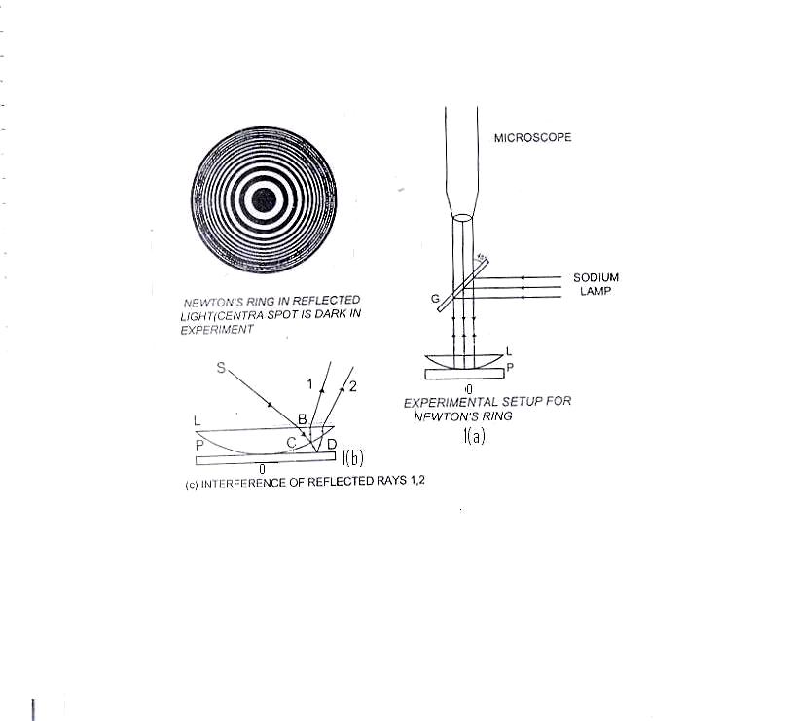

For air film μ = 1 and normal incidence r = o hence in this case, the path difference is 2t + λ/2 at the point of contact t& o and the path difference is λ/2, which is the condition of minimum intensity. Thus the central spot is dark. For n^{th} bright fringe we have

2t + λ/2 = nλ
As Δ = nλ [condition for max. intensity.]
and Δ = (2n ± 1) λ/2 [condition for min. intensity.]
Let R be the radius of curvature of the surface of lens in contact with the plate. λ be the wavelength of light used and D_{n} and D_{n+p} the diameter of nth and (n + p)th dark rings respectively, then
D²_{n} = 4nλR and D²_{n+p}= 4(n+p)Rλ
D²_{n+p --} D²n = 4Rpλ
R = D²_{n+p --} D²n
4pλ

Procedure:
- Adjustments:-
  - First the glass plate P, Plano convex L and the plate P are cleaned to ensure that there are no dust particles.
  - Now the light from the sodium light is made to fall on the convex lens L and the parallel light from the lens L fall on the Glass plate G which is kept at 45⁰. This ensure that light is falling normally on the system of Plano convex lens and the plane glass plate kept in contact beneath the glass plate G.
  - Note down the least count of traveling microscope.
  - Move the eyepieces to and for inside tube so as to adjust it such that cross wires are distinctly seen.
  - Focus the microscope to obtain distinct Newton’s rings in the field of view by lowering or rising up the microscope by rack and pinion arrangement.

- Measurement of diameter of rings:-
  - The Microscope is moved horizontally (say toward left) with the help of tangential screw and counting the rings, the cross-wire is made tangential on the 10th bright circular ring. The reading of microscope is noted. Now the microscope is gradually moved towards left and the reading of say 9, 8, 7, 6, 5, 4, 3, 2, 1 ring are noted.
  - Now keep on moving the tangential screw of the microscope in the same direction till 1st ring on the right hand side reached. Again note the readings 2, 3, 4, 5, 6, 7,8 ,9, 10. The difference in reading on the two sides of rings will be its diameter.

Observations:
Value of 1 division on the main scale of microscope (x) = ….cm
Total number of divisions on the vernier scale (n) = ……

Least count of microscope = Value of one small main scale division (x)
Total number of division on vernier scale

Wavelength of light used (Sodium light) λ = 5893Aº = 5893 x 10⁻⁸ cm

Observation table for the diameter of rings:

No. of rings | Reading of microscope |  |  |  |  |  | Diameter of rings  D=a-b  cm | D²(incm²) | D²_{n+p -} D²n  (in cm²)  P=5
No. of rings | On left side |  |  | On right side |  |  | Diameter of rings  D=a-b  cm | D²(incm²) | D²_{n+p -} D²n  (in cm²)  P=5
No. of rings | M.S.R. | V.S.R. | T.R.  (a)  cm | M.S.R. | V.S.R. | T.R.  (b)  cm | Diameter of rings  D=a-b  cm | D²(incm²) | D²_{n+p -} D²n  (in cm²)  P=5
10 |  |  |  |  |  |  |  |  | D²₁₀ -D²_{5=……….}  D²₉ -D²_{4=………...}  D²₈ -D²_{3=………...}  D²₇ -D²_{2=………...}  D²₆ -D²_{1=………...}
9
8
7
6
5
4
3
2
1

Mean D²_{n+p} -D²_{n=…….}

Calculations:
We have

D²_{n+p --} D²n
R =
4pλ

D²_{n+p --} D²n
R = cm
4pλ ×10⁻⁸

R=……………… cm

Result:
The radius of curvature of the given lens = …………. Cm

% Error: 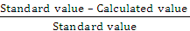x 100

= ------------------%
Standard value = 100 cm

Precautions:
- The glass plate, lens must be cleaned.
- The glass plate should be kept at 45⁰.
- The radius of curvature of the Plano convex lens must be large so that the large diameter rings may be obtained.
- The source must be monochromatic and extended.
- The tangential screw of the microscope must be moved in the same direction to avoid backlash error.
- While measuring the diameter the cross-wire should be tangential to bright ring.
- The glass plate or lens should not be touché with hands.

Viva Questions:
- Which phenomenon is responsible for the formation of Newton’s rings?
----------------------------------------------------------------------------------------------------------------
- What do you mean by interference?
------------------------------------------------------------------------------------------------------------
- Why do Newton’s rings circular?
------------------------------------------------------------------------------------------------------------
- Why is the centre of Newton’s rings dark?
----------------------------------------------------------------------------------------------------------------
- Why do the rings get closer as the order of the rings increases?
------------------------------------------------------------------------------------------------------------
- Why we use the extended monocromatic source of light in this experiment?
----------------------------------------------------------------------------------------------------------------
- Why are Newton’s rings known as fringes of equal thichness?
----------------------------------------------------------------------------------------------------------------

EXPERIMENT NO. 08

DIFFRACTION GRATING

OBJECTIVE:
To determine the wavelength of yellow and green light using diffraction grating.

APPARATUS REQUIRED:
Spectrometer, Diffraction grating, Sodium Lamp, Magnifying glass and spirit level.

THEORY:
When the parallel beam of light is incident normally on a grating of grating element (e+d), by Huygens‘s principle each point of slit emit out secondary wavelets in all direction which interfere and get focused in the focal plane of the convex lens. The path difference between the diffracted waves at an angle Ѳ from the corresponding points of two consecutive slits is (e+d) sin Ѳ. When the path difference is equal to the integer multiple of wavelength λ, the wave produces constructive interference. Hence the principle maxima is given by,
(e+d) sin Ѳ = nλ

FORMULA USED:
λ = (e+d).sin Ѳ/n
where (e+d) = 2.54 / N (Grating Element)
n = Order of spectrum
Ѳ = Angle of diffraction
N = Total no. of lines on grating.
CIRCUIT DIAGRAM:

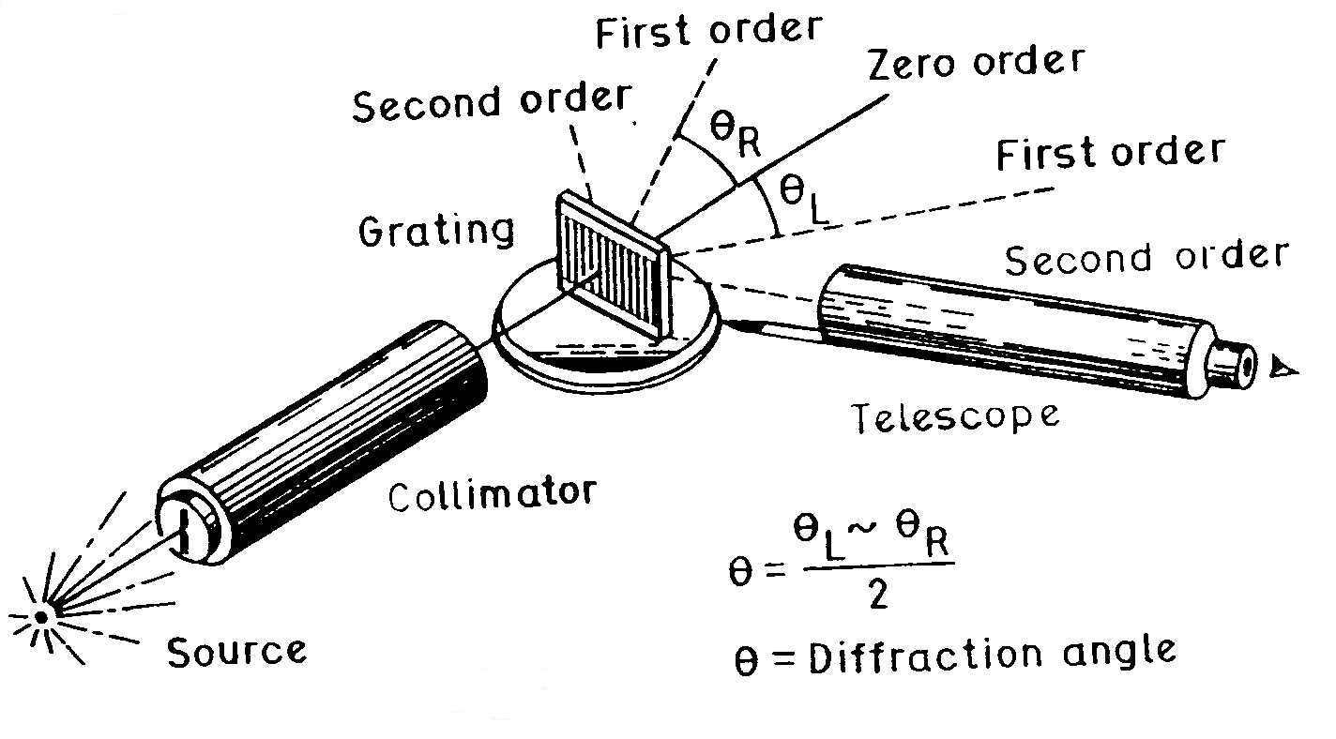

OBSERVATION TABLE:
Least count of spectrometer = Value of one division on the M.S.
Total no. of division on V.S.
One division on the main scale of spectrometer x = …
Total number of divisions on venire scale n = …
Least Count = x/n = …⁰
V₁ V₂
Position of telescope for direct image xº = ……… ……….
Position of telescope after turning by x + 90º = ……… …………
Position of prism table after turning by 45º= ………… .. ………

S. No | Order of Spectrum | Colour of spectrum |  | Position of Telescope on Left Hand side |  |  | Position of Telescope on Right Hand side |  |  | Difference (θ₁~Ѳ₂) / 2 | Mean  θ
S. No | Order of Spectrum |  |  | MS | V.S | T.R(θ₁) | MS | V.S | T.R(θ₂) |  | Mean  θ
1 | n = 1 | Yellow | V₁
1 | n = 1 | Yellow | V₂
1 | n = 1 | Green | V₁
1 | n = 1 | Green | V₂

CALCULATIONS:
Wavelength λ = (e+d).sin θ/n
Where (e+d) = 2.54 / N (N- no. of lines per inch on grating)
n = 1 (For first order)
λ = (e+d) sinθ
For Yellow Spectral Line
λ_{Y} = (e+d) sinθ_{Y}
= ------------------A⁰
For Green Spectral Line
λ_{G} = (e+d) sinθ_{G}
= ------------------A⁰
Result :- The Wavelength of Green Light λ_{G} =………………………Aº
The Wavelength of Yellow Light λ_{Y} =………………………Aº

PROCEDURE:
- Adjust the spectrometer and note down the least count of vernier scale.
- With the help of telescope image of slit is focussed on the cross wire and the reading of vernier scale is noted (let x º).
- The telescope is turned exactly by 90 º from x º and is fixed.
- Now the grating is mounted on the prism table. Prism table is then gradually rotated till the image of slit is focussed on the cross wire.
- Then prism table is turned by 90 º.
- Telescope from the position of direct image of slit is rotated towards left till the first order spectrum is seen in the field of view.
- Now the telescope is turned on the right side of the direct image of slit and again the reading of both verniers V1 and V2 are noted for the same spectrum lines in the first order spectrum.
- Same steps are repeated for second order spectrum.

PRECAUTIONS:
- The mechanical and optical adjustment of the spectrometer must be made correctly.
- The slit used should be as narrow as possible.
- Light from the lamp should be rendered approximately parallel.

VIVA QUESTIONS:
- What do diffraction grating glasses do to light?
----------------------------------------------------------------------------------------------------------------
- Why does a diffraction grating separate white light into colors?
----------------------------------------------------------------------------------------------------------------
- What is grating?
----------------------------------------------------------------------------------------------------------------
- What are advantages of diffraction grating?
----------------------------------------------------------------------------------------------------------------
- What is the use of grating element in laser experiment?
----------------------------------------------------------------------------------------------------------------

